Minutes of the Meeting of Friston Parish Council held in the Village hall on Monday 14th October 2024 at 6pm

Councillors present: | Also present:
Cllr Michael Mahony | Jess Palmer (Parish Clerk)
Cllr Mary Shipman | 15 members of the public
Cllr Wendy Ireland
Cllr Carole Slack
MINUTES

102/24 Apologies for absence – to receive and approve any apologies received
Cllr Carlaw sent his apologies.

103/24 Declarations of Interest and Requests for Dispensations
None declared.

104/24 Minutes of the previous meetings
Wendy Proposed, Mary seconded
The minutes of the previous meeting 02 September were unanimously approved.

105/25 Open Forum
An allotment holder raised concerns about untended plots impacting those nearby. The Council responded that they would review the allotment agreement and seek a resolution.
A member of the public asked where he can find the responsibilities of each Councillor. Cllr Mahony directed him to the Parish Council website. The member of the public then questioned whether those with properties bordering the Village Green require permission from the Council before they instruct contractors to access the Green in order to maintain their property. Cllr Mahony deferred to Cllr Carlaw to answer the question at a future meeting.
A member of the public praised a recent meeting in Benhall as an excellent synopsis of what is happening with the energy projects and congratulated members of Friston Parish Council for their work on keeping parishioners informed and engaged with the energy projects. Cllr Mahony updated the public on an upcoming event Energy Project Exhibition in Saxmundham.
A member of the public questioned the access Scottish Power would have on Grove Road and share concerns that the planned works, resulting is a three week road closure would be ‘significantly damaging.’ Cllr Mahony confirmed that they are aware of the issue and seeking to get to the bottom of it.
A member of the public thanked the Parish Council, particularly Cllr Carlaw for their swift action in clearing the mile-a-minute weed from the Village Green and re-seeding.

106/24 Councillors
The Councillors unanimously resolved to co-opt Shelley McNicol to the Parish Council.

107/24 County Councillor Reports
Delivered.

108/24 District Councillor Reports
Cllr Sarah Whitelock –highlighted the key t items in her report: a statement from Cllr Tom Daly and changes to waste and recycling which will be coming into effect in the next two years. Cllr Whitelock also highlighted East Suffolk Council’s safety survey. Action: The Clerk will circulate the survey among the Councillors and add it to the Parish Council website.
Cllr Whitelock reported on resources already in place to support wellbeing, and offered the Parish Council Suffolk Mind training days available to Councillors and residents. Action: Cllr Slack will liaise to make the arrangements. Cllr Whitelock reported that Suffolk Mind’s wellbeing survey will serve as a starting point for a customised survey for residents of Friston to assess the impact of the energy projects on their mental health. Cllr Slack relayed advice from Suffolk County Council’s mental health representative that the key is to prepare people before the survey and then share the results straight away so they can see the impact. She advocated for the Parish Council work together closely with Suffolk Mind and demonstrate to local people that the survey is driven by the Parish Council. The Council were unanimous in their support of the project. Action: Cllrs Whitelock and Slack will liaise to progress the project.

109/24 County and District Councillors Energy Project updates
Delivered.

110/24 Energy Projects
It was unanimously resolved that Friston Parish Council will join the East Suffolk Communities Energy Partnership.
Cllr Mahony delivered updates from meetings he had attended relating to the energy projects.

111/24 Wellbeing

Cllr Slack reported that the Warm Welcome grant funding application was unsuccessful, but the Chequers pub is still keen to open three mornings a week as a warm welcome. Friston Parish Council will provide a member to accompany people who attend.
It was unanimously resolved to pursue a relationship with the Rural Coffee Caravan. Action: Cllr Slack will make contact with them.

112/24 Name Change for National Grid Connection Hub / Substation
Cllr Mahony reported that East Suffolk Council and Suffolk County Council have both given support for the Parish Council’s request to change the name of the substation and that a letter has been sent to SPC.

Planning
It was unanimously resolved to respond to both planning applications with no comments.

113/24 Reports from other meetings
Cllr Ireland delivered a report from a meeting with Community Police about the community speed watch project. The area has been surveyed by Police and they agree that it is safe to host a speed. Cllr Ireland has arranged sufficient volunteers, the paperwork has been filed and she is awaiting confirmation from Community Police to begin.

114/24 Friston Watercourse
Cllr Mahony reported that a letter has been sent to Scottish Power with requirements from the Parish Council (as discussed at the Parish Council meeting held on 2nd September) in order to support their proposed actions relating to the Friston but no reply has been received as yet.
Cllr Shipman relayed a response from the Environment Agency stating that the watercourse is the responsibility of the riparian land owners. They also advised that silt of taken from the watercourse, cannot be disposed of by taking away – it must be left on the bank. Action: – Cllr Shipman will continue to liaise with all stakeholders.

115/24 Emergency Planning
Cllrs Slack and Ireland delivered a report from a recent training course and highlighted that in the event of a flood, Friston has no suitable building for those affected to shelter in. This is due to the low-lying position of the Village Hall and the lack of toilet facilities at the Church therefore Knodishall is the nearest location for emergency shelter. Suffolk County Council will not support with emergency supplies and resources unless they approve of the emergency sites of which Friston has three: The Chequers pub, the Church and the Village Hall.
Action: Cllrs Slack and Ireland will work in collaboration with Knodishall.
Cllr Mahony encouraged the Church to apply for funding to install toilets.
A discussion took place around the current emergency action plan. Action: The Clerk will begin work to re-draft the document. Action: Cllr Slack will send the Clerk information from the meeting she attended. And approach the owners of the Chequers pub owners for their involvement.

116/24 Village Green
An update from Cllr Carlaw was delivered.
Cllr Slack commented that the current activity of the Council is reducing biodiversity. A decision relating to the pruning of trees on the Village Green was deferred until next meeting.
The Clerk reported a request from a resident to bring a contractor’s vehicle onto the Green in order to maintain his property line. Cllr Shipman raised concerns that a large vehicle may cause damage to the Green if the ground is wet. It was unanimously resolved to allow the vehicle as long as the working areas if clearly coned off for safety, that judgment is used regarding the softness of the ground, and that any damage is repaired by the contractors.

117/24 RoSPA Play safety inspection report
The Clerk delivered the RoSPA safety report and its recommendations.
It was unanimously resolved to remove the springy plank play equipment and to install a sign giving contact details of the Clerk.
Action: The Clerk will seek a contractor to remove the plank.

118/24 Outdoor Playing Space fund
It was unanimously resolved to submit no objections to Snap Parish Council’s request to use the shared fund.

119/24 Financial Regulations
The Clerk delivered a precis of the proposed financial regulations which have been circulated to Councillors and welcomed questions or comments before the next meeting.

121/24 Village Hall
An update from Cllr Carlaw was delivered

122/24 Community Events
Cllr Ireland reported that the community calendar is now complete and copies are for sale.

123/24 Footpaths
Cllr Mahony introduced Gwyn Church – land agent for Blackheath and their new land contractor. Both shared their intentions for a more sensitive approach to local farming and welcomed any feedback from residents. Cllr Ireland noted that footpaths are a recurring issue, particularly their being reinstated after ploughing. Mr Church replied that it is dependent on weather and assured the Council that they plan to take a more pro-active approach going forward. Mr Church agreed to place a sign with a diversion in the short term when footpaths cannot be placed on their usual route though Cllr Mahony noted that the Parish Council cannot approve a diverted footpath but that we all have to work together for mutual benefit.
Mr Church stated that earlier in the year they emailed the Parish Council and County Council for a pre-approval for diverting footpaths around the edge of fields where dairy cows are present for safety reasons and that feedback from this had been positive.
Cllr Mahony thanked them both for attending.

124/24 Highways
Cllr Shipman delivered an update on the traffic calming measures. Suffolk County Council have declined to pay for replacement speed limit repeater signs and that covering this expense is now considered a responsibility of the Parish Council.
Speed enforcement have fined 10 people for speeding through the village.
Grit bins have been cleared ready for re-filling.

125/24 Allotments
The Clerk delivered a report of allotment occupancy.

126/24 Accounts
- Following a proposal by Cllr Ireland, which was seconded by Cllr Shipman, it was unanimously resolved to approve the Certificate of Exemption of the Annual Governance and Accountability Return.
- Following a proposal by Cllr Ireland, which was seconded by Cllr Shipman, it was unanimously resolved to approve the Annual Governance Statement (Section 1) of the Annual Governance and Accountability Return.
- Following a proposal by Cllr Ireland, which was seconded by Cllr Shipman, it was unanimously resolved to approve the Accounting Statements (Section 2) of the Annual Governance and Accountability Return alongside a supporting statement.
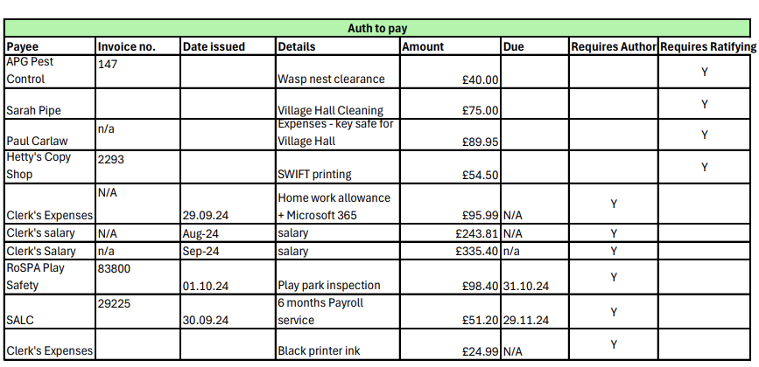
- The Clerk delivered an update on finances and accounts. The Council noted the payments, receipts and bank balances as at 9th October 2024. The council authorised or ratified all payments as detailed below:
- The Council unanimously resolved to approve the Clerk’s overtime to date at 16 hours and to increase her working hours to 8 per week temporarily. This will be reviewed ahead of the new financial year.

At the close of the meeting, Cllr Mahony resigned as Chair of the Parish Council.

The meeting closed at 8:15 pm

The next meeting of the Parish Council is on 2nd December at 6pm

Jess Palmer
Parish Clerk

